Project Design Phase
Solution Architecture

Date | 25 February 2026
Team ID | LTVIP2026TMIDS41392
Project Name | AI-Powered Multi-Language Translator using Gemini
Maximum Marks | 4 Marks

Solution Architecture:
Solution architecture is a structured process that connects business problems with appropriate technology solutions. In the TransLingua: AI-Powered Multi-Language Translator, the architecture defines how user inputs are processed through a web interface and translated using an AI-powered language model to deliver accurate multilingual results.
The goals of the solution architecture are to:
● Find an effective AI-based technological solution to overcome language communication barriers.
● Describe the overall system structure, components, and workflow for stakeholders and developers.
● Define application features such as text input, language selection, AI translation processing, and result display.
● Provide clear specifications for development, deployment, and management of the translation system.

Example - Solution Architecture Diagram:

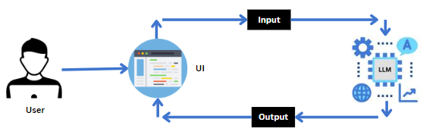
Figure 1: Architecture

